Name: S.M. ABRAR MUSTAKIM TAKI

ID:20301125

Visited Website: cspb.teletalk.com.bd

My IPV4 Address: 192.168.0.105

Website IP Address: 103.230.106.216

**Packets Request**

**Physical Layer**

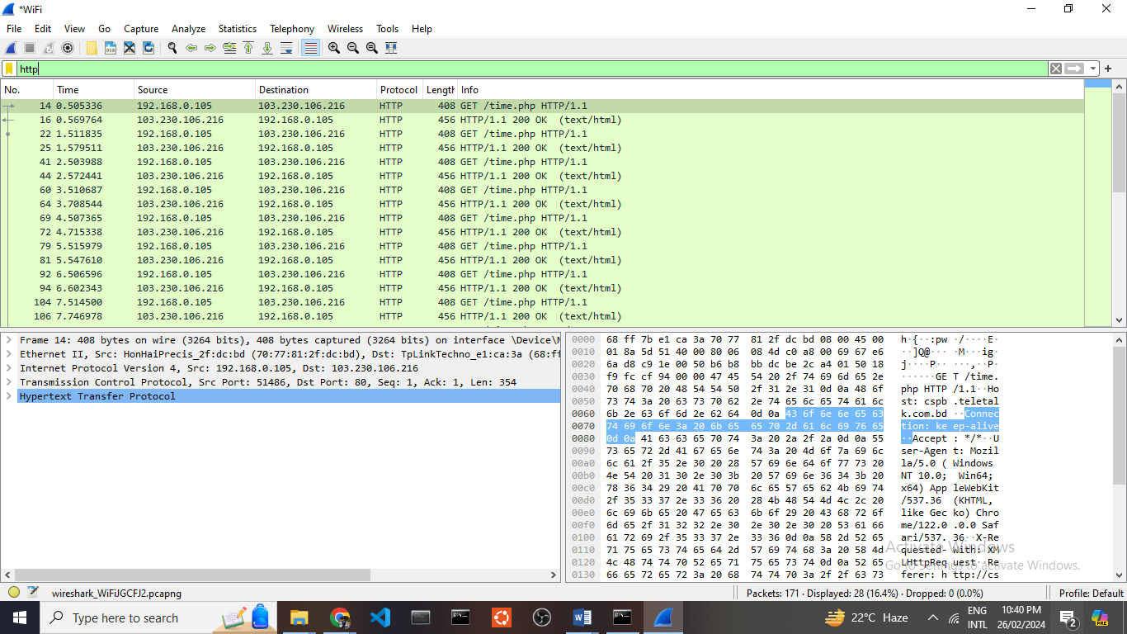  
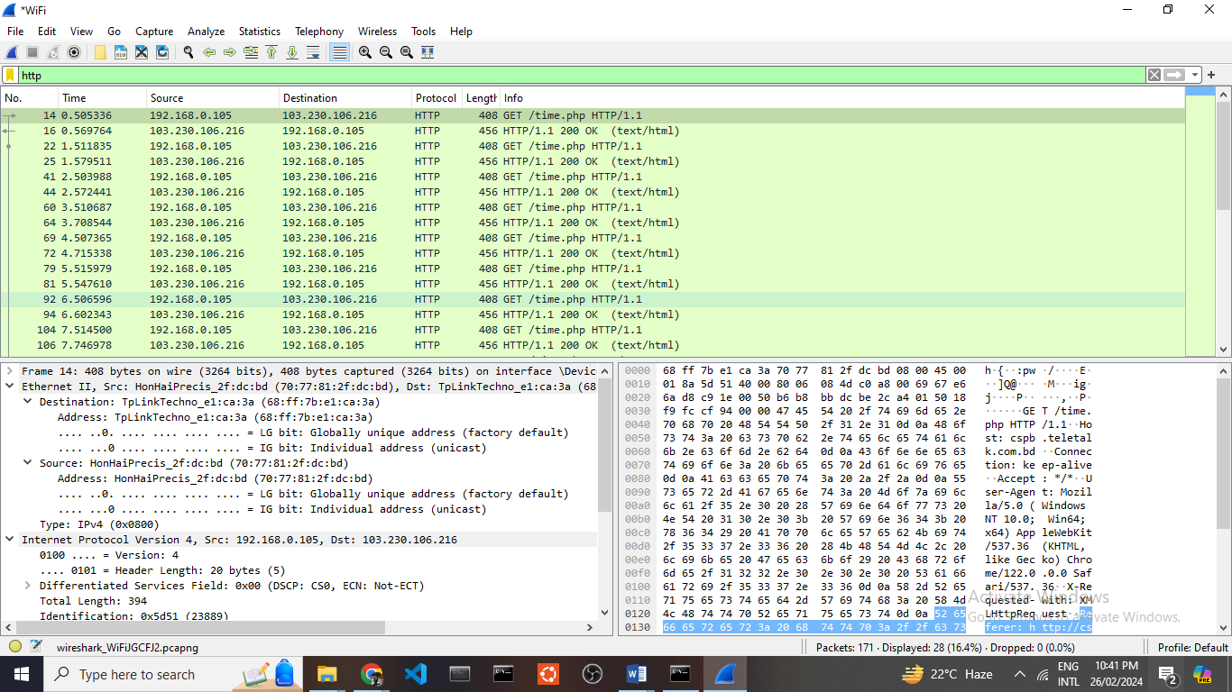

Ethernet operates at the network access layer within the TCP/IP model, and it functions within the Physical layer of the OSI model. Its primary role is to decide the optimal path for transmitting data packets over a physical network medium. It utilizes MAC addresses to represent the unique device address of the sender and the destination server address.

**Data Link Layer**

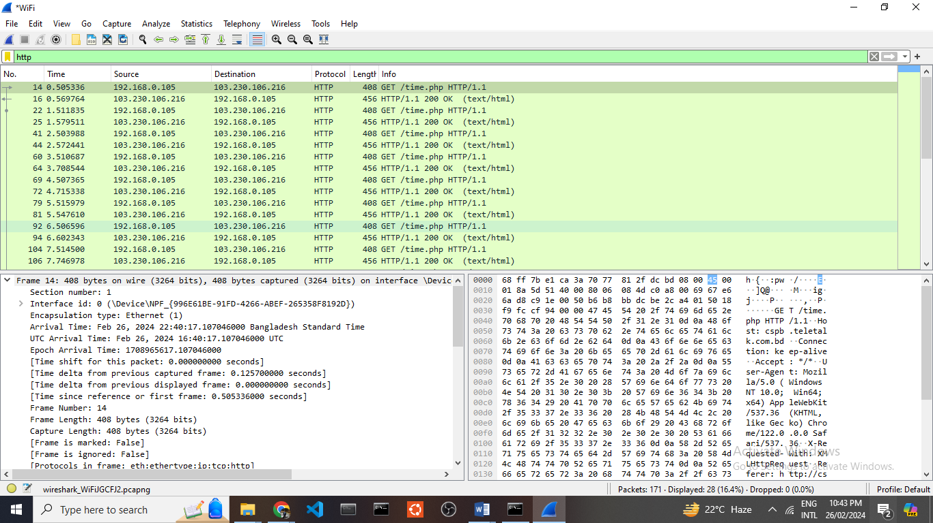

The Data Link layer in the OSI model and the Network Access layer in the TCP/IP architecture both involve the handling of data frames. Their main function is to calculate and verify checksums and identify the most efficient means of transmitting data over network media.

**Network Layer**

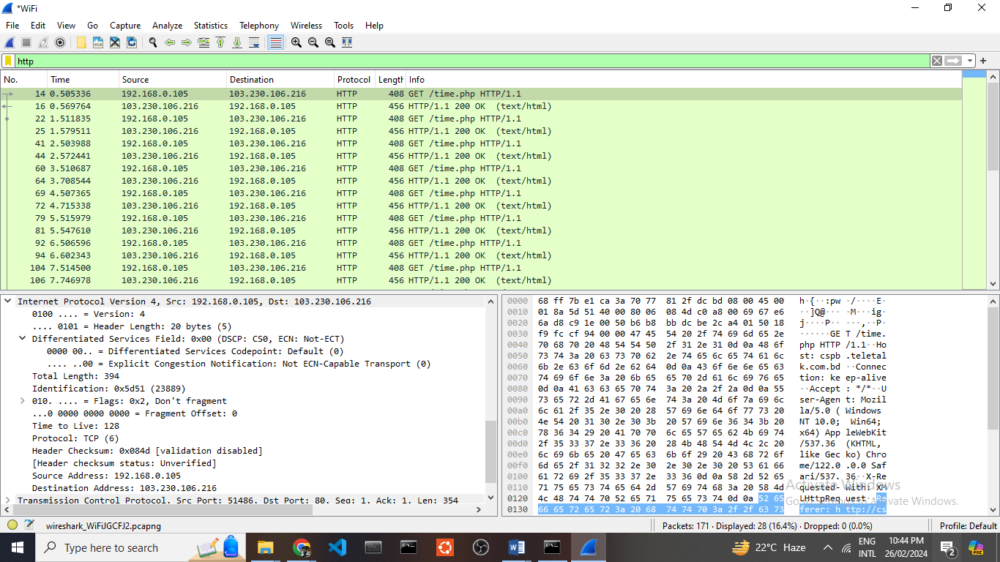

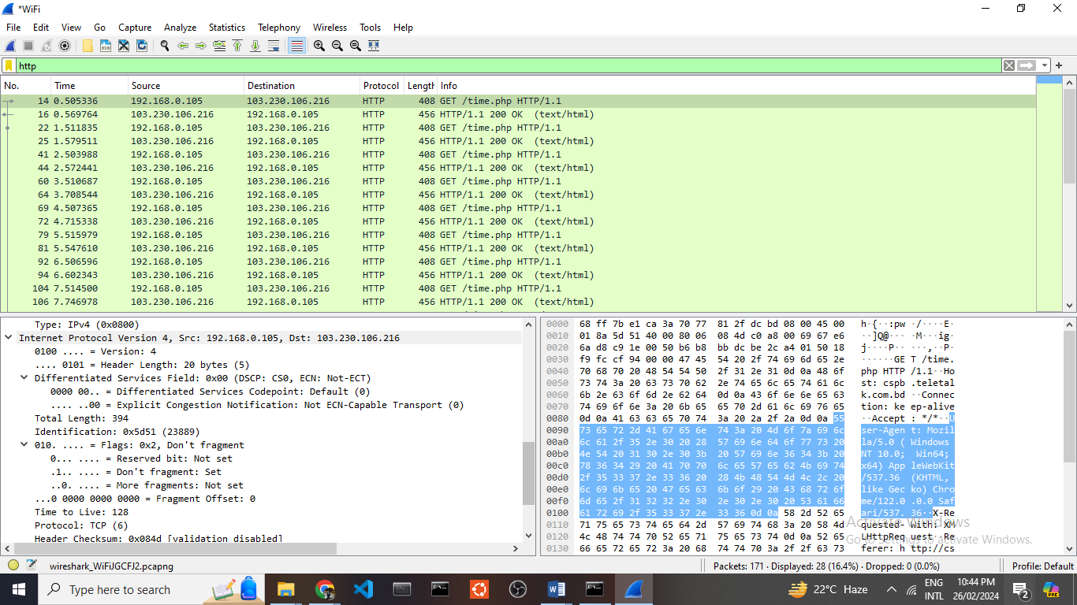

In this network layer, the IP address plays a crucial role in establishing a step-by-step connection. To illustrate, I’m making a request to the server by designating my device’s IP address (192.168.0.105) as the source, and the server’s IP address (103.230.106.216) as the destination.

**Transport Layer**

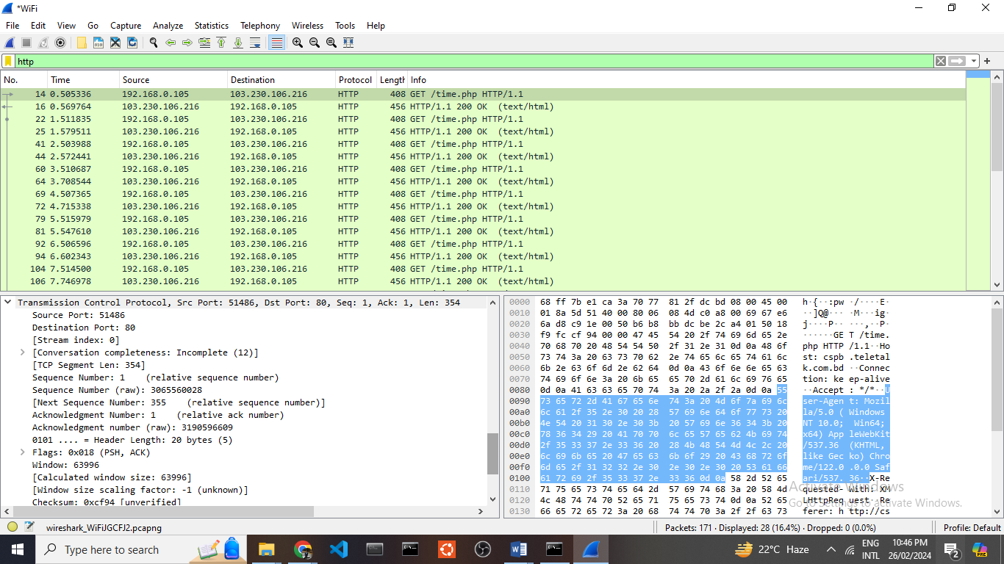

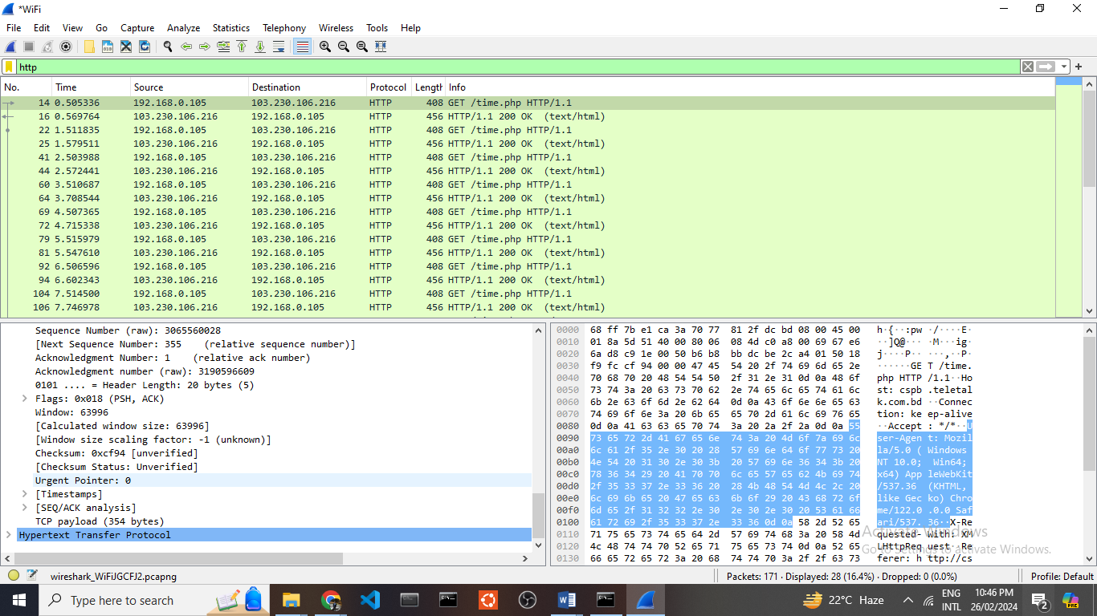

The Transport layer encompasses protocols such as TCP (Transmission Control Protocol). When a program is initiated either by the operating system or within our system, it is assigned a unique port address. Before establishing a connection with any website, a standard procedure known as the “three-way-handshake” is typically required. This process commences with our device initiating a TCP request to the server, which acknowledges the request. Subsequently, our device sends another TCP request for confirmation, and this exchange continues until the “three-way handshake is successfully confirmed.

**Application Layer**

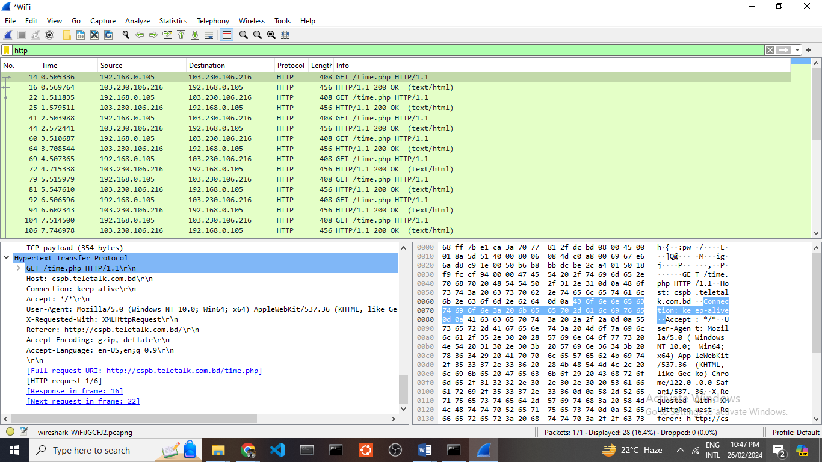

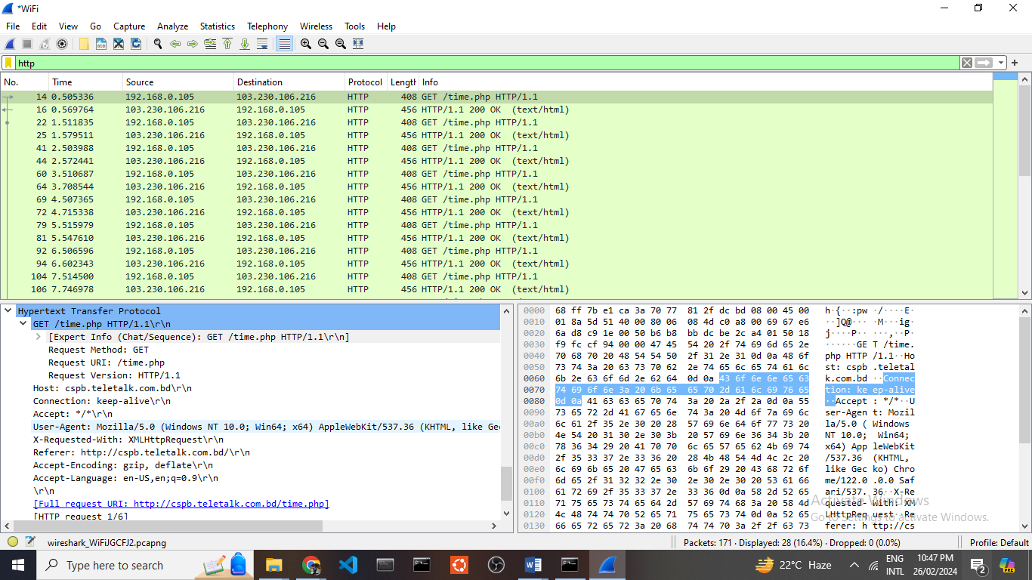

Within the Application layer, we find protocols like HTTP (Hypertext Transfer Protocol), which serve the fundamental purpose of fetching data from a server and presenting it to the client. Following the establishment of a three-way handshake, my device initiates an HTTP request to the server, seeking the required data for rendering or accessing a website. The server promptly responds with the requested data, and my device, upon receiving this information, may make additional requests for additional data while confirming the reception of prior data. It's essential to note that once all the necessary data has been acquired, the TCP connection is terminated. In its operation, HTTP reveals the Uniform Resource Identifier (URI) and the HTTP version, employing the POST method for sending an HTTP header. When it comes to data retrieval, the GET method is employed. After the successful transfer of files, the TCP connection is duly closed.

**Response Packet**

**Physical Layer**

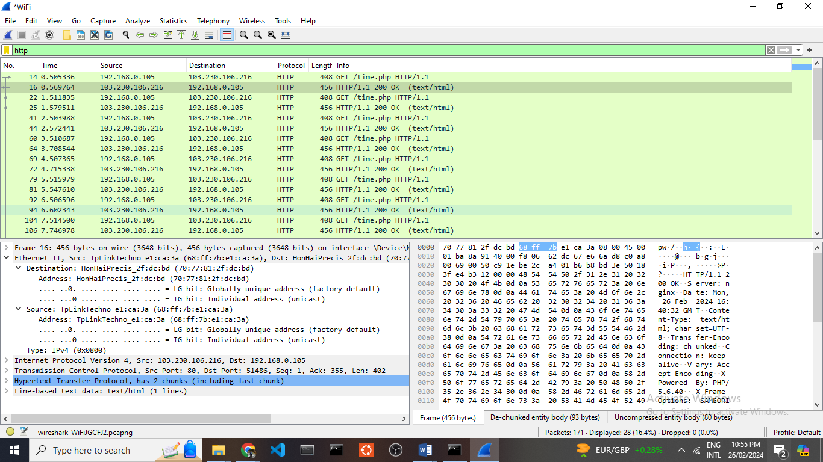

Ethernet operates within the network access layer of the TCP/IP model and aligns with the Physical layer in the OSI model. Its primary role involves ascertaining the most efficient path for dispatching data packets over a physical network medium. The device addresses, representing both the sender and recipient, are identified through MAC addresses.

**Data Link Layer**

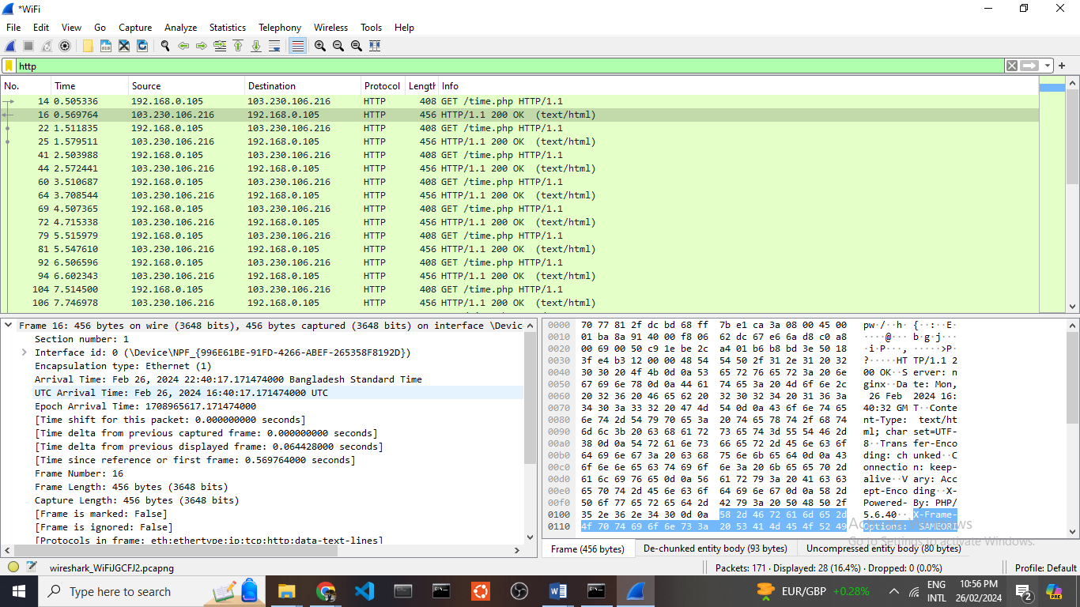

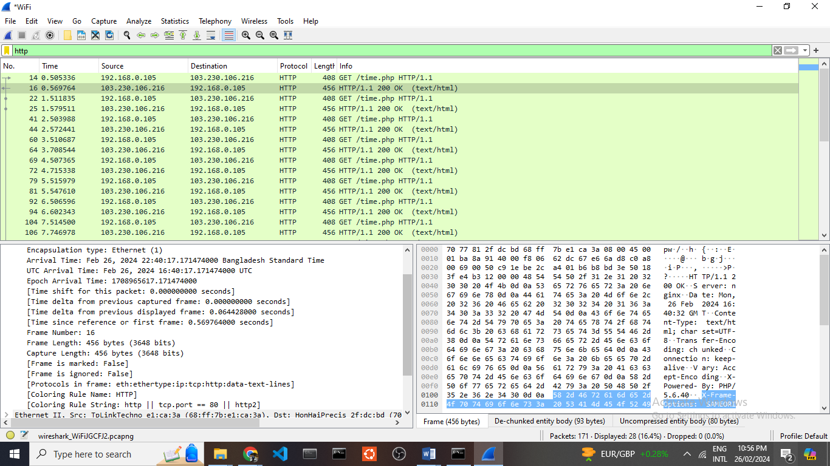

In both the OSI Data Link layer and the TCP/IP Network Access layer, frames play a vital role. Their primary responsibility is to calculate checksums and establish the optimal approach for transmitting data over network media

**Network Layer**

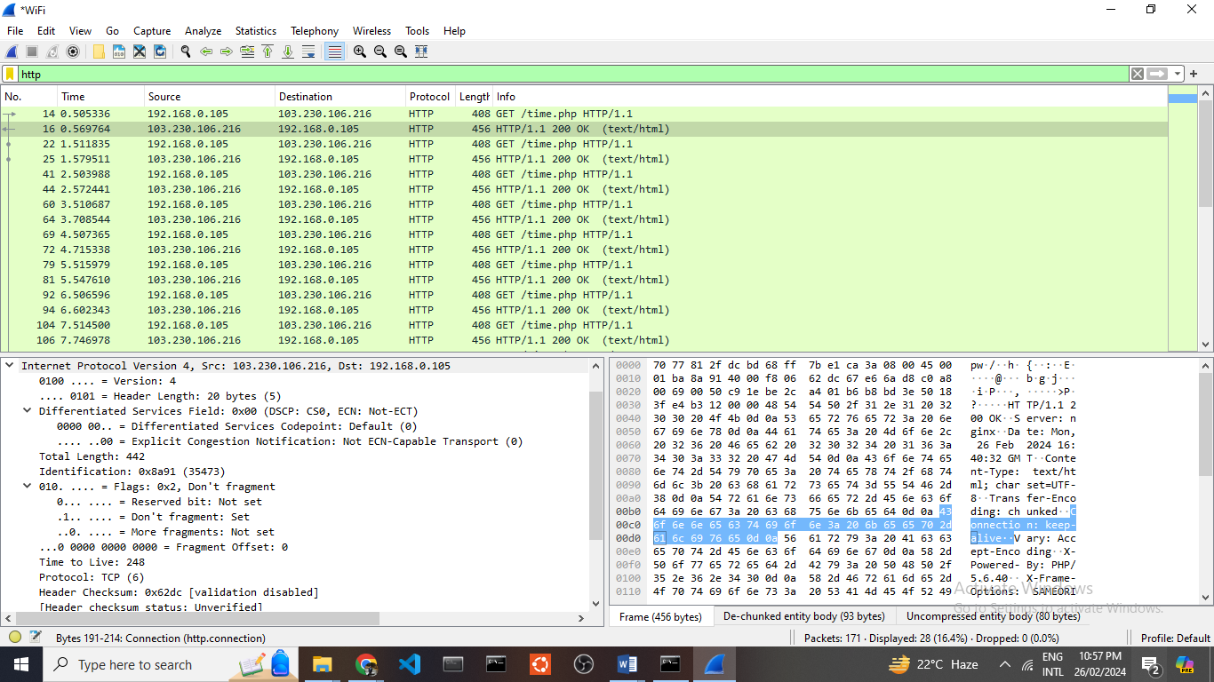

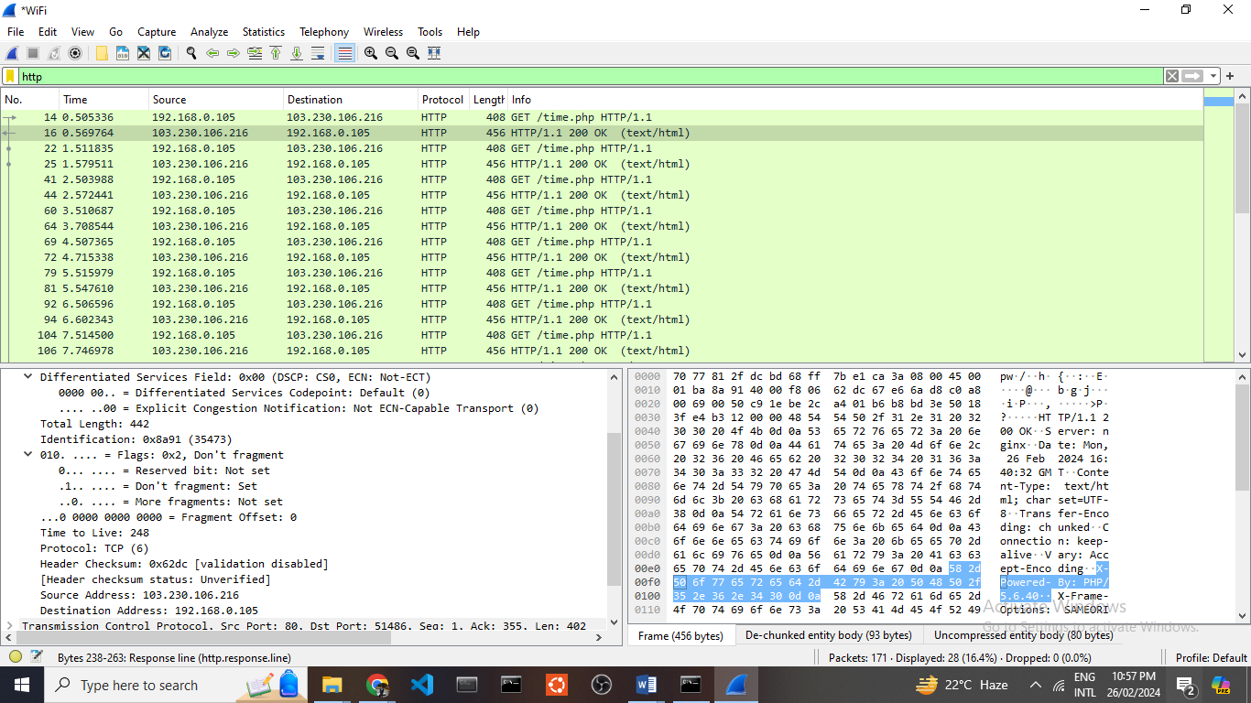

Network layer is responsible for hop-to-hop connection. It delivers the packets from source to destination. Here source is the server and it’s IP address is - 103.230.106.216and destination is my device and it’s IP address is - 192.168.0.105.

**Transport Layer**

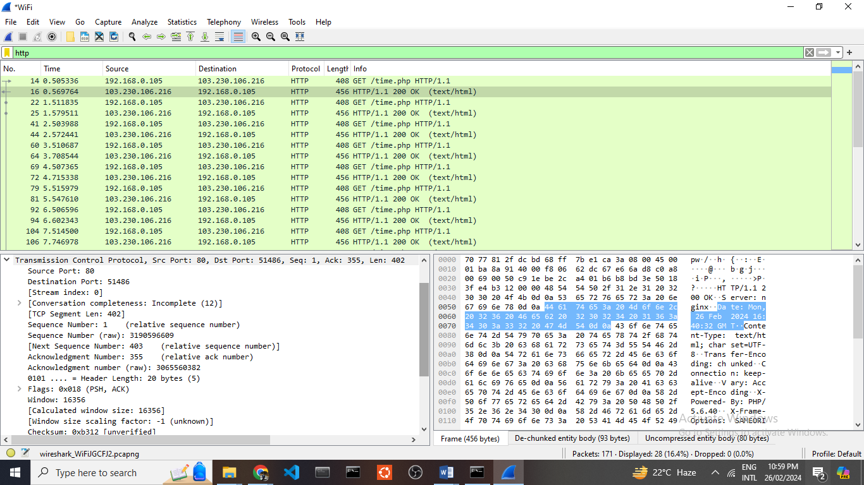

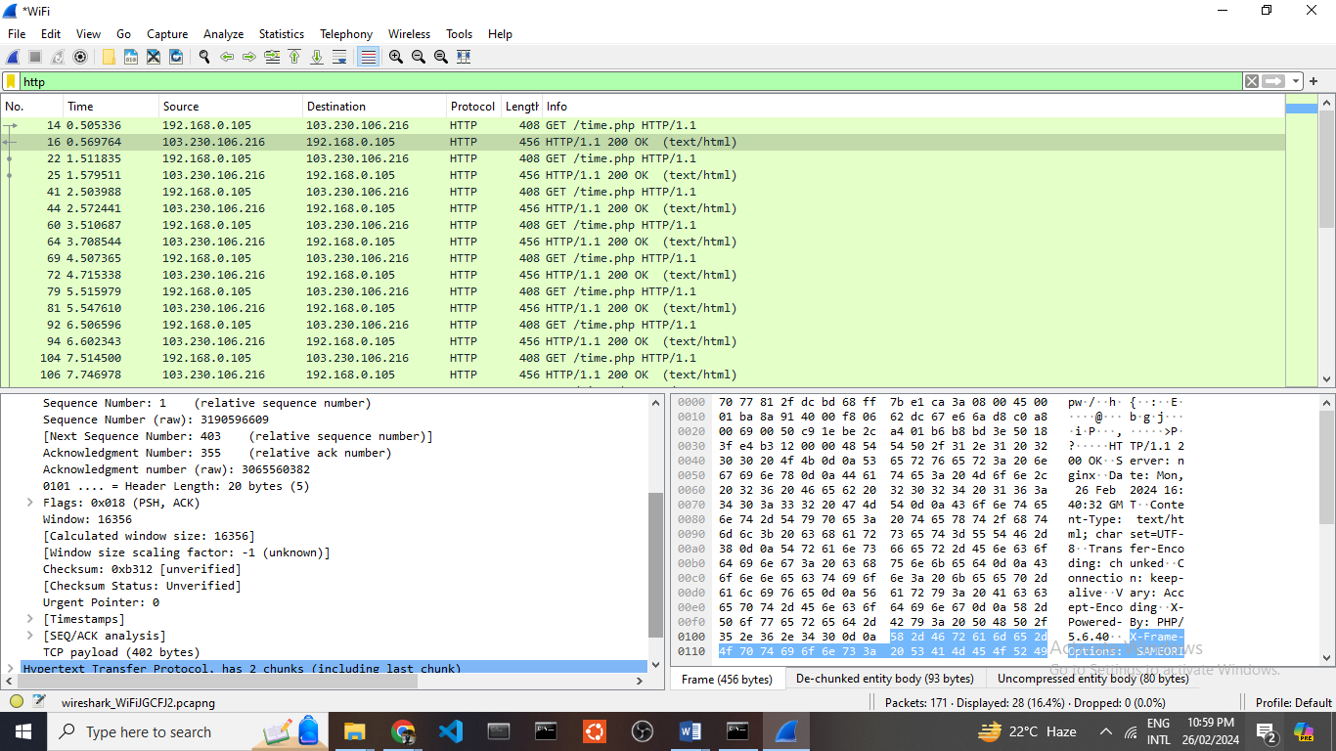

The Transport layer encompasses protocols like TCP (Transmission Control Protocol). When a program is initiated, either by the operating system or within our system, it is assigned a unique port address, serving as its distinct identifier. Prior to accessing any website, it's customary to follow a mandatory procedure known as the "three-way handshake." This process unfolds as follows: our device initiates a TCP request to the server, which promptly acknowledges it. Subsequently, our device dispatches another TCP request to seek confirmation, and this exchange persists until the three-way handshake is successfully verified.

**Application Layer**

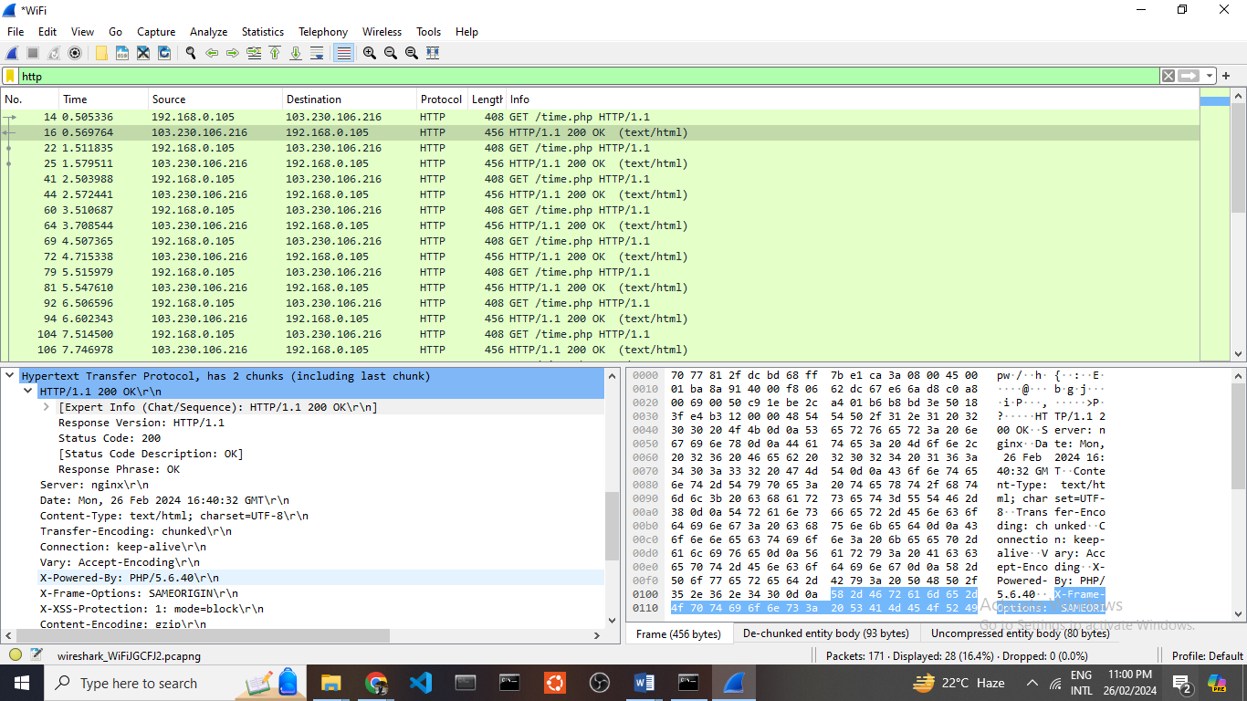

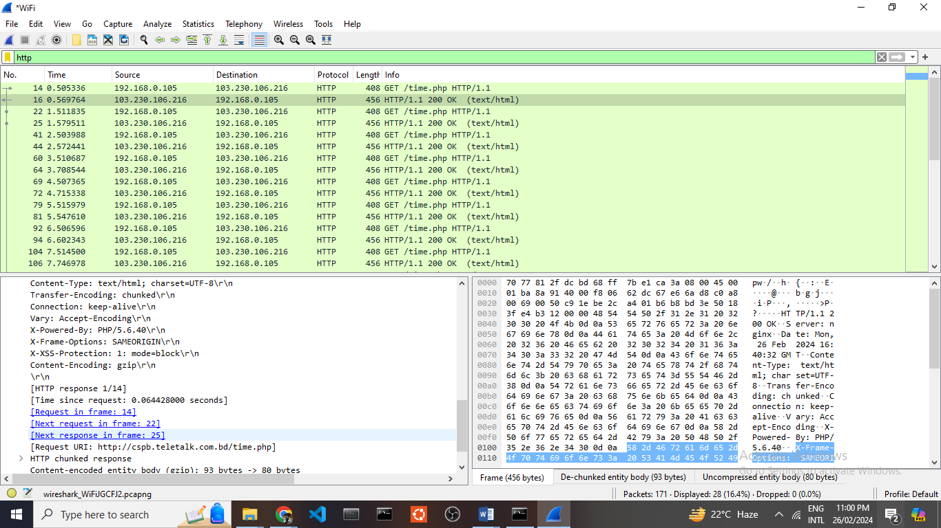

Within the realm of application layer protocols, HTTP (Hypertext Transfer Protocol) stands out as a notable example. The primary role of this protocol is to facilitate the transfer of data from a server to a client. In this scenario, my device initiates a three-way handshake, followed by an HTTP request to the server, requesting the essential data required for rendering a webpage. The server promptly responds with the requisite data, and my device may further seek additional information while confirming the receipt of previously transmitted data. Importantly, the TCP connection is closed once all the necessary data has been successfully retrieved. During this process, HTTP conveys essential information such as the HTTP version and the Uniform Resource Identifier (URI). It also employs the "200 OK" HTTP header for acknowledgments, and in addition to this, it presents various other details including the date, time, and other relevant facts.

**Command Prompt**

